Trading Made Simple(r)
I have named this thread as such because I learned so much from "Big E's" thread "Trading Made Simple" and I incorporated in some of the ideas and indicators he used, and some of how he used them. Furthermore, I would like to dedicate this thread to him, and may he rest in peace.
Although my templates do not include his main indicator which was the TDI, they do include other indicators that I find much easier to read than the TDI. For example, Big E (Eric) would talk about when the TDI started to bend, or arch, or flatten out, etc. as exit signals which I found to be way too subjective for me, so I eventually dropped it. And, he mentioned that he might drop it also because he could still trade very successfully without it. In other words, he didn't really need it either.
He also seemed to mostly like trading the 4 hour charts the best, and the daily charts to a lessor extent. He practically begged people to stop trading the lower time frames because you get whipsawed so much. I completely agree with him and suggest that you do the same. However, if you MUST day trade, I would suggest only day trading the 15 minute charts. But what you do is on you. These templates work just the same on any time frame.
For those of you who have not read Eric's thread "Trading Made Simple", I suggest you read it if you have not already.
Eric actually started talking about his method to a great extent in one thread, and then eventually created his own thread. Here they both are if you are interested:
Craig Harris Stochastics Method
https://www.forexfactory.com/showthread.php?t=211188
Trading Made Simple
https://www.forexfactory.com/showthread.php?t=291622
Big E PDFs:
Here are some .pdfs someone else made that contain of most of the significant things Eric wrote in those threads.
Attached File
Best of Big E I.pdf 1.4 MB | 3,328 downloads

Attached File
Best of Big E II.pdf 130 KB | 1,576 download
----------------------
Moving On...
I am creating this thread as a way of hopefully giving something back to this trading community, and to the many traders on this forum that have unselfishly given me the opportunity to learn so much from them. EVERY custom indicator I use (as far as I know), I downloaded for free from this forum.
The two templates that I am providing have evolved over the course of more than a decade. And, they may continue to evolve even more over time if we find useful things to add or change. Nothing here is set in stone, EXCEPT my way means always trading with the trend, and that means: at the start of what appears to be a new trend, or the resumption of a previous trend.
Now, what's UNUSUAL about my templates is that there is not just one, or just two or even 10 ways to trade them. There are MANY, and I am sure that there are more that I have not even uncovered yet.
Currently, I use 7 indicators to show me things like: where and when to enter and exit, where to place my stops, and sometimes where to place my profit target, market direction, turning points, trend, convergence, divergence, etc.
I will start off for now by explaining just two of the ways that I trade using the templates, but I suspect that over time other traders here will expose some of the other ways they discover, as will I also.
What you must understand is that what's presented, as it's presented, is NOT a trading system. A system has concrete rules with no variables. Methods don't. What I am presenting are trading methods, tips, and suggestions. Multiple trading methods about ways to enter and exit trades (with others likely to follow). The only concrete rules there are, are the ones that you decide to make and follow.
I have attached a zip file containing both templates and all indicators
I am sure that I have forgotten to mention or make clear lots things and so I'll add, correct, or clarify them as we go along.
And keep in mind, there is no Holy Grail trading system, and there is no winning without some losing.
At this point, I don't visit this forum every day. I trade, I own a business, and I travel quite a bit. I have done all 3 for more than 20 years and so I am often unavailable or too busy doing other things to be on the forum. If you have any questions for me, and you don't hear from me, I will be back as time permits.
My hope is that other traders will recognize the power of these templates and contribute even more ways to trade them, hopefully in ways even more effective than I have presented, and that they help traders make a lot more money trading the Forex.
----------------------
Templates:
# 1 (Used on 4 Hour, Daily, Weekly and Monthly Charts)
# 2 (Used on 1 Hour and Lower Time Frame Charts)
* The only difference between the two templates is that Template # 2 includes a market Open and Close times indicator, which would mainly be used for intraday trading. Mine are preset with the London Open and Close times and the U.S. Open and Close times (based on Eastern Standard Time). They can easily be edited to suit your preferences and time zone. I like being able to visually see when different markets open and close.
* Personally, I only trade 4 hour charts and daily charts and I only use Template # 1.
----------------------
Templates and Indicators
Attached File
# 1 and # 2 Template and Indicators.zip 90 KB | 3,909 downloads
----------------------
Template # 1
Indicators Used
Upper Window:
Yellow Line = 5 EMA, Shift + 2, Close
HMA Line (Hull Moving Average) = Period: 12, Method: 3, Price: 0 - Colors: Lime Green and Deep Pink
Heiken Ashi - Blue and Maroon
Synergy_APB - Doger Blue and Red
Bar Clock - DimGray
Magnified Market Price
Lower Window:
RSI 14 - Sienna/Brown
Stochastic - 8,3,3 - SlateGray (Thinner Line), Lime, Gold
Stochastic - 14,3,3 - SlateGray (Thicker Line), Blue, Red
50 Line - BlueViolet (I refer to it as Purple)
Template # 2 (Only Used for Intraday Trading or Chart Watching on lower Time Frames)
It is exactly the same as Template # 1 but it also includes an indicator called: JF_TradingTimes that shows you when particular markets open and close.
Note: None of these indicators repaint after the bar has closed.
--------------------------
Two Basic Trade Entry Methods Explained
Please Note: At first, it will seem like there are a lot of indicators and things to remember using these templates, but I can assure you that once you understand how each indicator works, and what the colors are telling you, it all becomes VERY simple. I will post some charts showing examples of each, and show some ways that I use them.
Indicator Colors
> Green and Blue Colors Always Mean "UP"
> Reddish and Orange-ish Colors Always Mean "Down"
> None of the Other Colors Used Have Any Meaning
Crossover Trades:
1. The HMA Line is Lime Green and crosses above the Yellow Line for long trades OR the HMA Line and is Deep Pink and crosses below the Yellow Line for short trades.
2. The candles must have just changed from Dodger Blue/Blue to Red/Maroon for short trades or from Red/Maroon to Dodger Blue/Blue for long trades.
3. After both # 1 and # 2 above have occurred, preferably, you want to initiate a trade after the 1st bar has closed on the same side of the Yellow Line as the direction of the trade or on the 2nd or 3rd candle ideally. Entering any later than that is more risky.
4. The trade set-up bar is the 1st candle to cross over the Yellow Line AND is the opposite colors of the previous candles. Both bars must either be: Red/Maroon or Dodger Blue/Blue. Red/Maroon for short trades or Dodger Blue/Blue for long trades. The set-up candle must close before you enter a trade.
5. The 2 Stochastic Lines must be above, or crossing above the Purple 50 Line for longs OR below for shorts.
6. The RSI Line (Brown) must be on the same side of the Purple 50 line as the direction of the trade at the time of entry.
Continuation Trades:
A Continuation Trade is when there has already been a trade in that direction, but you were stopped out OR got out for some other reason and then you get another signal to enter in the same direction.
You can go long again if a bar turns back to Dodger Blue/Blue after being Red/Maroon or Red/Blue AND the Dodger Blue/Blue bar's close is above the Yellow Line and all other indicators agree.
You can go short again if a bar turns back to Red/Maroon after being Dodger Blue/Blue or Red/Blue AND the Red/Maroon bar's close is below the Yellow Line and all other indicators agree.
Variation(s):
If all indicators imply long, and the Stochastics 8,3,3 (the thin SlateGray Line) retreats below the Purple 50 Line, then it crosses back above the Purple 50 Line and all indicators still imply long, you can enter long.
If all indicators imply short, and the Stochastics 8,3,3 (the thin SlateGray Line) retreats above the Purple 50 Line, then it crosses back below the Purple 50 Line and all indicators still imply short, you can enter short.
Plus, Remember This Too
There are MANY different indicators included or combinations of indicators included that you could use to enter trades. For example, you could use:
1. Just the Yellow Line
2. Just the HMA Line
3. Just one of the Stochastics, or a combination of both
4. Just the candles changing colors
5. Just the candles and the HMA Line
6. Just the HMA Line and the Yellow Line
Etc. etc. etc.
--------------------------
Exit Methods
Just some of the possible ways...
1. Candles change to the opposite color(s)
2. RSI crosses the Purple 50 Line in the opposite direction
3. HMA Line turns the opposite color
4. A candle closes on the opposite side of the Yellow Line
5. One or both Stochastics cross the Purple 50 Line in the opposite direction
6. The HMA Line and the Yellow Line cross to the opposite direction
7. Stop Loss (including a trailing stop) gets hit
8. Profit Target is reached
9. The market stalls, or slows down to a crawl, or gets choppy
10. The trend changes direction
11. Plus many others, such as: Fibonacci spots, support and resistance areas, retracements, time of day, holidays, weekends, etc.
--------------------------
Stop Placement Methods
For Long Trades: Just below the low of the 2nd candle back behind the bar you entered on
For Short Trades: Just above the high of the 2nd candle back behind the bar you entered on
Note: You can put the stop at the high or low 1 candle back, but it will get hit much more often
--------------------------
Charts
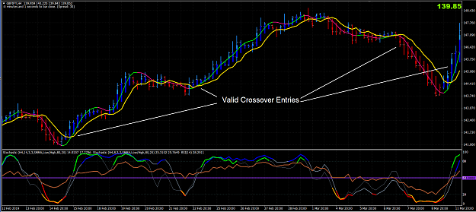

Attached Image (click to enlarge)
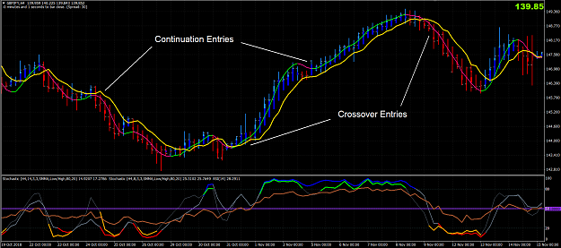
--------------------------
Trading Tips:
When using the Crossover or Continuation methods for entries, it is best to enter on the 1st, 2nd, or 3rd candle after the HMA Line crosses the Yellow Line. Otherwise, it is usually better to wait for the next trade set-up. This is because, as Big E used to preach, most often candles only run the same colors for 3-8 bars.
When using the Crossover or Continuation methods for entries, ideally, you should only enter if BOTH Stochastic have crossed the Purple 50 Line (in the direction you are trading), or if one has crossed and the other is very close to crossing the 50.
You MUST wait for the set-up candle to close before you enter OR exit a trade, otherwise it may close the wrong color(s) and you don't want to trade that.
It's often much riskier to enter a new trade immediately after an exceptionally large bar. So it's not suggested that you do it.
Whenever you enter a trade, make sure that the last bar has closed on the same side of the Yellow Line as the direction you are trading in.
When the two Stochastics cross in unison (or very close together), it's usually a better than average trade set-up. But, you also need the other indicators to agree before you enter.
Always enter a stop loss immediately when you place a trade.
DON'T enter a new trade during the first hour after the open because the spreads are usually exceptionally wide. If I get a signal to enter on the Open, I enter just a few minutes BEFORE the Open when the spreads are still normal.
When you get a signal to enter on the 4 Hr. or Daily chart, drop down to the 1 min. or 5 min. chart and only enter when they are moving in the same direction as the entry signal.
Personally, I don't like to enter a trade when the previous bar closed in the opposite direction of my trade. I usually wait to enter until after a bar has closed in the direction of my trade. It's a momentum thing.
Trading Books I Suggest You Read:
Phantom's Gift
Attached File
Phantom's Gift.pdf 371 KB | 419 downloads | Uploaded Jul 2, 2019 9:03am
Way of the Turtle
Attached File
Way of the Turtle - Curtis Faith.pdf 968 KB | 287 downloads | Uploaded Jul 4, 2019 12:21am
More are coming!
--------------------------
In Conclusion...
This may sound harsh, but I really believe that if you cannot eventually learn to make money trading the Forex using these templates, then you should probably just give up trading the Forex.
Here is a .pdf containing everything in this post (Thanks goes to Luttlebird who created it)
Attached File
Trading Made Simple(r) by Uncle R (Robinhood) .pdf 453 KB | 1,398 download | Uploaded Jun 14, 2019 10:11am
And Lastly...
If you are blatantly rude, obnoxious, insulting, or try to dissuade others in the thread with false information, you will be placed on IGNORE without warning (which means that you will no longer ever be able to post in the thread). No one wants those disruptions. We are here to help each other by teaching, learning, or both and so we need a nice, cordial environment that EVERYONE feels welcome in.
==============================================
ADDENDUM - 7/16/19
For those of you who may be struggling to get a good percentage of winning trades, here's what I suggest.
ONLY trade Continuation Trades on a 4 hour chart for now, and only until you perfect trading them. Do not take any Crossover Trades.
In my opinion, for people who are relatively new or inexperienced at trading OR have not yet been consistently successful at trading, Continuation Trades are easier to trade and more reliable than Crossover Trades (until you perfect them) because you are almost always jumping in on an ALREADY established trend, in the di-2019rection of the trend. You are "going with the flow". You are swimming down river. Both of which are easier than reversing course, which is what Crossover trades do.
I would also suggest (just while you are learning) that you place your stop just above the high of the candle 2 candles behind the candle you entered on for short trades and place your stop just below the low of the candle 2 candles behind the candle you entered on for long trades. If your risk tolerance is low, then place the stop 1 candle back, but you WILL lose more trades than if you place it 2 candles back, but you will also lose less per trade when you lose. It's up to you, but do one or the other, and whichever way you do it, do it consistently.
I would also suggest (just while you are learning) that whatever size your stop is in pips, that you also set a profit target for the same amount of pips. Set both immediately just after you place your trade. NO EXCEPTIONS. Make this a habit or you WILL live to regret not doing it.
Why I am suggesting that you trade this way (just until you get consistently profitable) is because it's like learning to ride a bicycle and using training wheels. Once you get good enough at trading this way, just as on a bicycle, you can take the training wheels off.
Here are some examples of Continuation Trades:
Attached Image (click to enlarge)
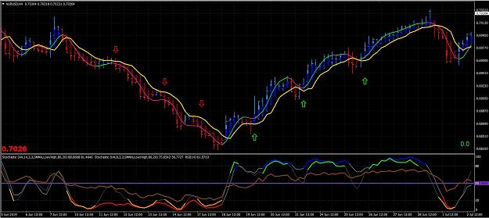
To Be Continued...
Emulate What Works

Trade Entry Examples
I want show and explain some textbook long entries for the two types of trades I discussed in my opening post. They are a Crossover Trade and a Continuation Trade.
Attached Image (click to enlarge)
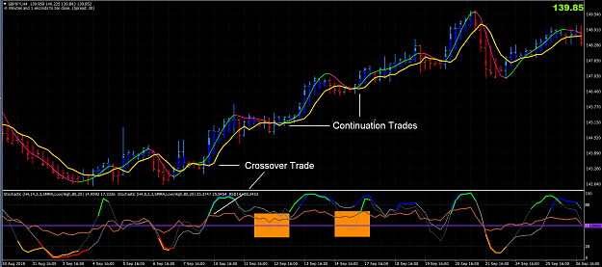
Long Trades Entries Explained
Crossover Trades (Example of a Long Trade)
1. The HMA Line turns Lime Green and crosses above the Yellow Line
2. The candles turn from Red to Dodger Blue/Blue
3. A bar closes above the Yellow Line
4. Both Stochastics (lower window) are above (or are crossing above) the Purple 50 Line
5. RSI (Brown Line, lower window) is above (or is crossing above) the Purple 50 Line
Continuation Trade (Example of a Long Trade)
At some point during a Crossover Trade you may get stopped out or have exited for some reason. For example, the candles may have changed to the opposite color or a bar closed below the Yellow Line, etc.
Here's how a Long Continuation Trade works:
1. A long Crossover Trade was just recently in effect
2. One or more candles changed from Dodger Blue/Blue to Red (or Red/Blue)
3. The HMA Line is currently Lime Green and never crossed below the Yellow Line
4. The RSI remained above the Purple 50 Line
5. The 14, 3, 3 Stochastic remained above the Purple 50 Line
6. One or more candles change back to Dodger Blue/Blue
7. The 8, 3, 3 Stochastic (it's the thinner SlateGray line) dips below the Purple 50 Line and comes back up through it. That is the final signal to enter. * Refer to the chart shown below, in the lower window. Notice the Orange boxes. They show the 8, 3, 3 Stochastic and what I just described.
Short Trades Entries Explained
(I'll put a chart here later when I have more time showing some short entries)
Crossover Trades (Example of a Short Trade)
1. The HMA Line turns Deep Pink and crosses above the Yellow Line
2. The candles turn from Dodger Blue/Blue to Red/Maroon.
3. A bar closes below the Yellow Line
4. Both Stochastics (lower window) are below (or are crossing below) the Purple 50 Line
5. RSI (Brown Line, lower window) is below (or is crossing below) the Purple 50 Line
Continuation Trade (Example of a Short Trade)
At some point during a Crossover Trade you may get stopped out or have exited for some reason. For example, the candles may have changed to the opposite color or a bar closed above the Yellow Line, etc.
Here's how a Short Continuation Trade works:
1. A short Crossover Trade was just recently in effect
2. One or more candles changed from Red/Maroon to Dodger Blue/Blue (or Red/Blue)
3. The HMA Line is currently Deep Pink and never crossed below the Yellow Line
4. The RSI remained below the Purple 50 Line
5. The 14, 3, 3 Stochastic remained below the Purple 50 Line
6. One or more candles change back to Red/Maroon
7. The 8, 3, 3 Stochastic (it's the thinner SlateGray line) rises above the Purple 50 Line and comes back down through it. That is the final signal to enter.
* With Continuation Trades the 8, 3, 3 Stochastic does not have to cross above or below and back through the Purple 50 Line to be a valid Continuation Trade entry. I just wanted to show a clear example of one good way you can enter a Continuation Trade.
Emulate What Works

8

Quoting kirinda
RobinHood, you have many suggestions for exit. What exit method(s) do you prefer yourself? Regards Paal
I prefer letting the market take me out of a trade because you never know how far a move will go.
I like to place my initial stop as described below:
For Long Trades: Just below the low of the 2nd candle back behind the bar you entered on
For Short Trades: Just above the high of the 2nd candle back behind the bar you entered on
Note: You can put the stop at the high or low 1 candle back, but it will get hit much more often
Also, I trade the 4 hour charts more often than any other time frame. BUT I refuse to wake up to check my trades every 4 hours.
> During the day, depending on whether I can monitor a trade or not, I either move my stop every 4 hours in the way as described above (meaning to every 2 bars back) OR I place a trailing stop X pips away.
> At night when I am asleep, I either leave my stop in the same place, OR I place a trailing stop X number of pips away.
In both instances, it all depends on how the market is acting OR how much profit I want to protect OR to limit the number of pips that I want to give back if it reverses course.
Emulate What Works

3

Good sense of humour calling Weekly grandmother, Daily mother and ....4Hourly daughter. LOL.
I keep a rather simple routine.
When Monday market open at my end (NY Open Sunday) I scan through my watchlist 20 pairs Weekly charts and look for new setups and if there is already an established trend after a recent CROSSOVER, I will drop down to Daily. If Weekly shows that price bars HA candles are small and trapped within its HMA and 5EMA, I skip the pair. I wait until there is a new price move outside the HMA and 5EMA.
Then I scan through all my daily charts and see if there are new CROSSOVER setups or CONTINUATION setups. If there is any, I simply open my positions.
If Daily shows established trend after a recent CROSSOVER, I'll wait on H4 for setups.
Doing it this top down approach, I will always find some good trading opportunities during the week.
How I allocate my account money to trade each pair is my other grandmother story...
Example EURJPY below, no trading for two weeks when price 'trapped inside HMA and 5EMA.
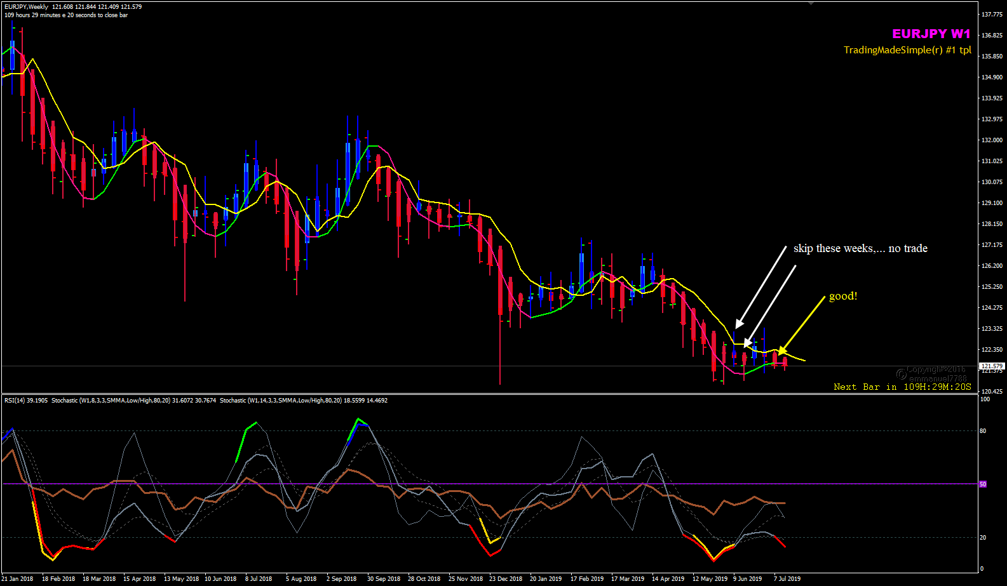

Quoting paroucia
{quote} Thanks Man Do you use just the indicators and see your chart? Or you look at PA at higher timeframe or anything beyond that you said in first post? Best Wishes
That is something that I have wrestled with and I've never found out which way Eric did it. Maybe someone else who knew his methods well can tell us. Personally, at this point, I don't think there is any one right way to do it.
I do ONLY use the template (# 1) and indicators that I provided, BUT I do also always look at the next higher time frame to see what it's telling me by way of putting Template # 1 on it. If the higher time frame chart is in an extended trend, I usually won't trade against it. Otherwise I often do.
The least risky way to trade is to only trade in the same direction next as the higher time frame. But the problem is, for example, if you trade the 4 hour chart and then look at the daily chart, should you then also look at the weekly chart, and then the monthly chart???? All 4 charts rarely point in the same direction at the same time. So then what?
Emulate What Works

2

Quoting Yudax
Robin, Congratulations on your new thread. Keep it up and surely I will be following and trying this system. Just want to ask how long have you been doing and trading this own system of yours? Thank you.
I have been trading some version of it for many years. As I have found better indicators I have incorporated them in and removed others.
At this point, I don't see how much more I can improve it. That's why I finally posted it.
Two of the best aspects of it is how close you can place your stop loss, and how easy visually it makes it to ride a good trend.
Attached Image (click to enlarge)
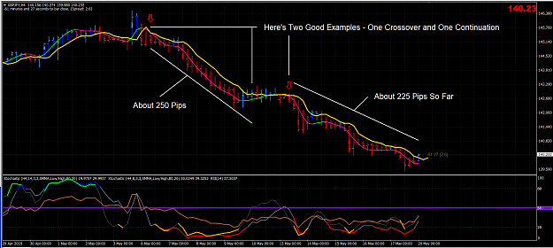
Emulate What Works

Quoting neil001
{quote} Hi Emmanuel - your charts show arrows that no-one else does - are they manually drawn arrows to highlight an item/point or are they Indicatoer drawn? Cheers Neil

Quoting Chosen3000
{quote} Hello @emmanuel7788 what's the red/blue arrow you are using on your chart?
Hi,
I am testing an alert indicator to see if it works properly according to RobinHood's Crossover condition i.e. the HMA crosses the 5EMA,Close,Shift+2 Yellow Line.
Want to be sure that there is no repainting of the Up/Down arrows on live charts.
It is not intended to be trade signal but to send alert so that traders can analyse their own charts for buy or sell trade opportunities.
Let me finish the tests by this week and I will communicate with RobinHood and see how it can be of use in his thread.
Please wait for further update on this.
Trade Well, be discipline and follow the rules in Post#1.
Honesty is a very expensive gift. You wont find it in cheap people.WBuffett

4

Quoting Yudax
{quote} Thank you Rob, Really really late .I entered because I saw the setup and wanted to make sure if I did the rules correctly. --- May I ask how many pairs do you trade?
It fluctuates a lot. It mostly depends on my mood. There's really no rhyme or reason why I trade what I trade. If I have a losing trade on a pair and it upsets me enough, I just switch to a few other pairs for a while. If I have a big winning trade on a pair. I may only trade that pair for a while but I trade it bigger.
I like trading the GBPJPY 4 Hr. chart the best. I also like trading several of the JPY crosses. And, as of late, I like trading the daily USDTRY because it has been trending so well.
Emulate What Works

Quoting Yudax
Rob, How do you determine SnR on your trades? Or do you neglect them in trading?
I don't use them too much for making trading decisions, but I am always "aware" of them.
That's why in post # 65 I said:
"we are in an area of what could be support again and I want it to "GO" or stop me out with a small loss."
The problem is (in my opinion) is that sometimes those areas hold and it seems that nearly as often, they don't. So how can you make trading decisions that have an edge if you are using using an indicator like that? I can't.
I prefer to just let the indicators (in the template I provided) tell me which way the market looks likes it's going and get on board in that direction, and when it stalls or reverses, I get out.
Emulate What Works

Quoting Yudax
{quote} Thank you. So when all the indicators tell you do buy. You just buy right away? Same as to sell.
In the case of Crossover Trades...
I can't give you a definitive answer on Crossover trades, because for me it's more complicated than just yes or no.
I usually look at one time frame up to see what it's doing and I look at a 5 and/or 15 minute chart to see what they are doing.
So if I get a buy signal (on Crossover trades) meaning "all the indicators tell me to buy" on the 4 hr. chart and the daily chart is in a confirmed downtrend, I am probably not going to buy, but if the weekly and the monthly are in a uptrend, then I might would take the long trade.
Also, if I decide to buy after looking at all that, I look at a 5 minute chart and I only enter if or when it is going up.
In the case of Continuation Trades...
When the conditions are right (and the set-up bar has closed), then YES I just enter right away.
Trading the continuation or the resumption of a trend has a higher % of wins than any other type of entry I use.
My advice is: Trade the resumption of a trend after a pullback (or it stalls).
Trading the resumption of a trend after the first pullback (or it stalls) is usually the best one. Each successive one after the first one gets progressively less reliable and more risky.
As an example: When numerous candles in a row are all blue, and the HMA line is Lime Green it's above Yellow Line, and the 2 Stochastics and the RSI are all above the Purple 50 Line you are probably in a uptrend.
THEN...when the candle(s) turn red/red or red/blue and/or the HMA Line turns Deep Pink BUT it stays above the Yellow Line AND the 2 Stochastics (or just the 14, 3, 3 Stochastics) and the RSI are all above the Purple 50 Line then the market is probably pulling back or stalling.
THEN... when a candle turns back to blue/blue, AND the HMA line turns from Deep Pink back to Lime Green AND it is still above Yellow Line, AND the 2 Stochastics and the RSI are all above the Purple 50 Line that is the resumption of the trend and you should re-enter.
Here's what 3 of them look like (in this example, on the chart below, the exits are based on when the candles turn red/red and close below the Yellow Line).
Attached Image (click to enlarge)
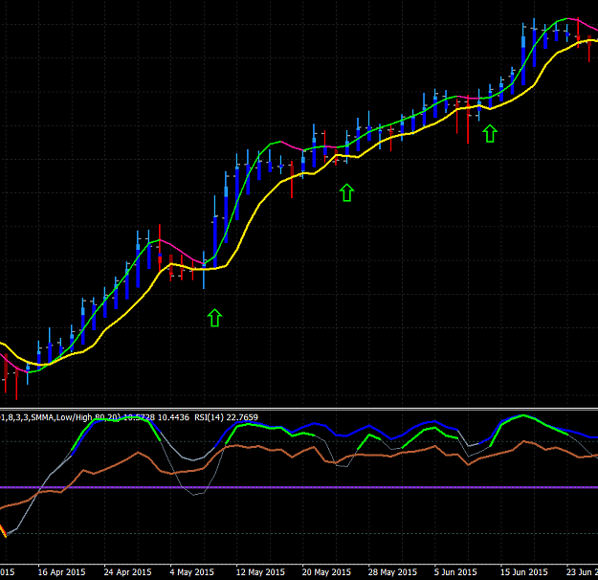
Emulate What Works

3

Quoting kirinda
{quote} Used the following method to exit the trade: 6. The HMA Line and the Yellow Line cross to the opposite direction AUDNZD -10pips I think the entry was according to the rules, but when I look at daily timeframe the trend is weak. This week I will check the daily before crossover trades to make sure that I have a clear trend.
While there is no right or wrong way to exit (based some of the ways I listed on page 1)...
Waiting to exit until the HMA Line crosses the Yellow Line will often be the last and very latest signal you could use (based on the 7 trading indicators in the template).
I prefer to exit when the first 2 or 3 indicators change colors (or cross, or be crossed) because I take that as they are signaling me to exit (and no, they won't always be right) or to move my stop loss closer.
I do it this way because I want cut my losses short and let my profits run. I don't have any problem with taking small losses, it's taking big losses that disturbs me.
Some of the ways you could use to exit are:
1. Candles change to the opposite color(s) AND the HMA Line turns the opposite color
OR
2. RSI crosses the Purple 50 Line in the opposite direction AND the HMA Line turns the opposite color
OR
3. A candle closes on the opposite side of the Yellow Line AND the HMA Line turns to the opposite color
OR
4. RSI crosses the Purple 50 Line in the opposite direction AND A candle closes on the opposite side of the Yellow Line
OR
5. One or both Stochastics cross the Purple 50 Line in the opposite direction AND RSI crosses the Purple 50 Line in the opposite direction
OR
6. One or both Stochastics cross the Purple 50 Line in the opposite direction AND a candle closes on the opposite side of the Yellow Line
OR
7. The HMA Line turns the opposite color AND the RSI crosses the Purple 50 Line in the opposite direction
OR
8. Any other combination(s) that you decide that you prefer OR use more than just one way which is what I do.
You have to remember, what I have presented are METHODS to trade...not a SYSTEM. You have to develop your own way(s) of using these methods (indicators).
Emulate What Works

5

kirinda,
One important piece of advice, only trade in the same direction as the RSI (14).
RSI (14) > Purple 50 Line = LONG ONLY
RSI (14) < Purple 50 Line = SHORT ONLY
Emulate What Works

Quoting salimc
Hello RH, I cannot follow the chart for various reasons. So at present, I want to use longer TF. Anyway, I have some questions for you. 1. Sometimes 4 H and Daily TF don’t agree with each other. So I am using D Chart. Any comment? 2. You use APB indicator along with HA candles. Is there any specific reason for that? 3. For your own trading do you use the present template? Thanks.
Question 1. "Sometimes 4 H and Daily TF don’t agree with each other. So I am using D Chart. Any comment?"
No matter what time frame you are trading, you always look for confirmation of direction from a higher time frame. If you are using the Daily time frame, go up to the Weekly for confirmation of direction (using Template 1). If the Weekly is going in the same direction as the Daily, then you have confirmation. There are no concrete rules regarding this (it's just how I do it), and so ultimately, it's up to you how you do it.
Question 2. "You use APB indicator along with HA candles. Is there any specific reason for that?"
They are 2 different indicators based on 2 different concepts that give 2 different results. Sometimes they agree with each other, and sometimes they don't. I will only enter a trade when they agree with each other and then once in a trade, when they don't agree with each other, I use that as a early warning signal that the trend may be about to stall or change.
Question 3. "For your own trading do you use the present template?"
Of course, it's absolutely the ONLY thing I use. It has 7 indicators that when used together can tell you when to enter, when to exit, where to place your initial stop, where to trail your stop, AND it works on any time frame. What more could you possibly need?
Emulate What Works

5

Quoting salimc
Quoting RobinHood
{quote} Question 1. "Sometimes 4 H and Daily TF don’t agree with each other. So I am using D Chart. Any comment?" No matter what time frame you are trading, you always look for confirmation of direction from a higher time frame. If you are using the Daily time frame, go up to the Weekly hello RH, Sorry to bother you again. My Question no. 2. was "You use APB indicator along with HA candles. Is there any specific reason for that?" your answer was "They are 2 different indicators based on 2 different concepts that give 2
...
Marking a chart isn't necessary because the explanation is so simple:
If the Synergy APB and HA candles are both Blue & Dodger Blue then they are in agreement. It means UP or Long only.
If the Synergy APB and HA candles are both Red & Maroon then they are in agreement. It means DOWN or Short only.
If they are Red & Blue then they are in disagreement.
Emulate What Works

2

Quoting harnying
Hi Rb, Would like to check with you when you are checking bigger tf with confirmation trend, what indicator are you looking at bigger tf? Hma, candle, ma, stoch, rsi, all of them pointing the same direction?
It's simple. I put my template on every chart I use. If I am trading a 4 hr chart, I simply switch it to a Daily chart OR if it's a pair that I trade a lot, then I set up a trading profile in MT4 that looks like the image below.
IDEALLY, I want all of them pointing the same direction on the next higher time frame, and if I can get them going the same direction on 3 higher time frames...it's even better. This happens to be the case with the EURAUD right now (see the chart below):
Attached Image (click to enlarge)
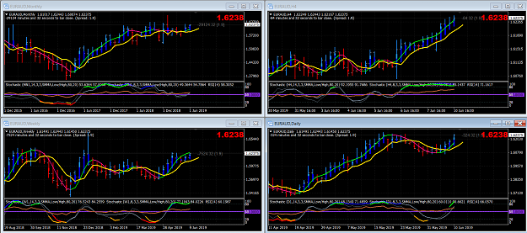
Notice there are 4 charts. The 4 Hr, the Daily, Weekly and Monthly.
NOTE: I don't REQUIRE that all 4 time frames be going in the same direction to make a trade (it's just IDEAL), sometimes I just require that the next higher time frame to be going in the same direction. For example: 4 Hr & Daily OR Daily and Weekly.
Emulate What Works

5

Here's a new Continuation Trade I got in a couple of hours ago based on a 4 Hr. chart. I will likely turn it into a Daily trade if it keeps going down for long enough.
Attached Image (click to enlarge)
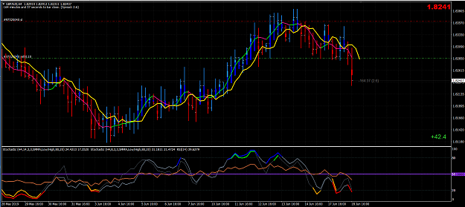
Emulate What Works

1

Here's a suggestion to help you time your entries better...
As I am sure that everyone has experienced, it often seems like right when you enter a trade, the trade immediately goes against you.
Since most traders on this forum didn't previously trade the 4 hr and/or the Daily charts as I suggest, I'll tell you how I usually enter a trade and mostly avoid that issue.
Using the 4 Hr chart to trade (and Template 1) for example, as soon as I get a signal, I look at the Daily chart to see if it's is going in the direction that I want to trade. If it does, then I drop down to a 1 min and 5 min chart to time my entry better. I only enter a trade when both are going in the same direction I want to trade.
And just like everyone else, sometimes I break my own rules, BUT NO MATTER WHAT, I ALWAYS drop down to a 1 min and 5 min chart to time my entries better.
Emulate What Works

6

Quoting juantrader
Example where the pair GBPJPY is about to cross the purple 50 line to be able to place a short order in H4, although in the Daily, the color of the candles are in blue yet. The trend is clearly bearish, and the dash also promotes short. RobinHood may you check this please? Thank you {image}
Taking a 4 hr. trade that is going against the Daily trend often works because the 4 hr. chart has to turn before the daily chart does, but it's more risky. Each trader has to decide which way suits them best.
Emulate What Works

Quoting jgadefelth
{quote} Can you describe method 2 more please how you do this ? Thank You Best regards
It's all on Page 1, Post # 1, but I will try to make it a bit clearer with 3 trading examples on the charts below.
Continuation Trades:
A Continuation Trade is when there has already been a trade in that direction, but you were stopped out OR got out for some other reason and then you get another signal to enter in the same direction.
You can go long again if a bar turns back to Dodger Blue/Blue after being Red/Maroon or Red/Blue AND the Dodger Blue/Blue bar's close is above the Yellow Line and all other indicators agree.
You can go short again if a bar turns back to Red/Maroon after being Dodger Blue/Blue or Red/Blue AND the Dodger Red/Maroon bar's close is below the Yellow Line and all other indicators agree.
Variation(s):
If all indicators imply long, and the Stochastics 8,3,3 (the thin SlateGray Line) retreats below the Purple 50 Line, then it crosses back above the Purple 50 Line and all indicators still imply long, you can enter long.
If all indicators imply short, and the Stochastics 8,3,3 (the thin SlateGray Line) retreats above the Purple 50 Line, then it crosses back below the Purple 50 Line and all indicators still imply short, you can enter short.
Attached Image (click to enlarge)

1. Reference the 2 orange boxes on the chart in the lower window.
a) Directly above them in the upper window, notice that just before both orange boxes, we were in an uptrend (meaning: HMA line was green and is above the Yellow Line, candles were blue/blue, price is above the Yellow Line, both Stochastics and the RSI are above the Purple 50 Line).
b) Then the green HMA line turned pink and some of the candles changed from blue/blue (meaning UP) to red/red (meaning DOWN) and the price closed below the Yellow Line.
2. In the lower window look at the orange boxes. Notice that Stochastics 14,3,3 (the thicker SlateGray Line) and the RSI stay above the Purple 50 Line BUT the Stochastics 8,3,3 (the thinner SlateGray Line) has dipped below the Purple 50 Line.
3. Wait for the candles turn blue/blue again AND the HMA Line turns green again (and is above the Yellow Line again), AND price is above the Yellow Line again. Then when the Stochastics 8,3,3 (the thinner SlateGray Line) crosses back above the Purple 50 Line that is how and exactly when you enter a Continuation Trade.
* The exact time you enter is bolded.
-----------------------------------------------------------------
Here's a Short Continuation Trade...With a Slight Variation
Attached Image (click to enlarge)
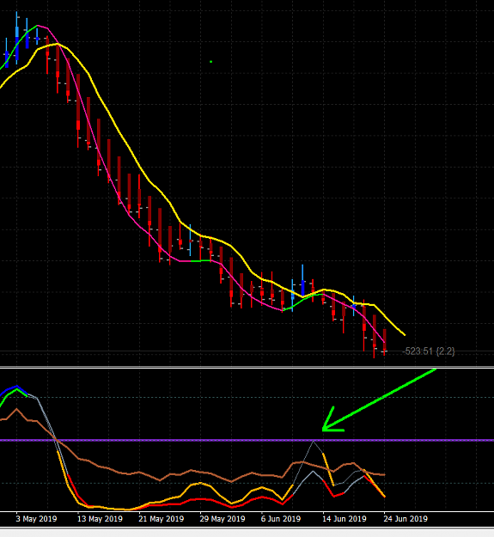
All the same rules apply as outlined above, BUT notice how the Stochastics 8,3,3 doesn't actually cross the Purple 50 Line, it just gets very close. And that's good enough too. Usually, the more shallow a pullback is (which is what the Stochastics 8,3,3 is signaling in this case), it's a sign that the trend is strong and wants to continue.
Emulate What Works

2

Here is a nice AUDUSD Continuation Trade I entered on the 4 Hr. chart yesterday. Notice how I keep moving my stop up, locking in profits all along the way?
I'll post the exit when it happens and why I chose to exit.
Attached Image (click to enlarge)
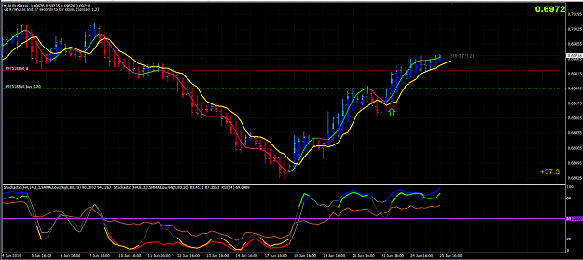
Emulate What Works

Quoting SuperPip
{quote} Hi! May I ask why you entered there? Candle color changed couple of candles back. Wasn't this entry too late? SP
It's easiest to learn and understand how the indicators change colors by watching them on a 1 minute chart. They don't actually work real time in the way you would think they would when you look at a chart later.
You can't enter a trade UNTIL the bar has closed.
The HMA line changes color but not permanently until after touching 2 bars, then, ideally, you should enter on the Open of the 3rd bar.
In actuality, I got in early BECAUSE I saw the bars turn blue/blue AND all 3 lower indicators were above the Purple 50 Line.
People MUST REMEMBER that these are "methods", lots of different methods, NOT A SYSTEM with fixed rules.
Emulate What Works

1

Quoting kirinda
{quote} Giedrius, very good point. I think I will continue to put on trades only based on the setup rules outlined by RoobinHood.
on days when there is key news / data release, I would have look at the higher timeframes and see where the established direction is and place y SL above or below the previous 2 days high or low, then do my positions size.
news/events reaction spikes seldom takes out stop more the 2 days high/lows unless there is a change ind direction after the news event.
example below showing H12 tiemframe today, the direction is clear before the news event and after the news hour, the direct has not changed.
Now I can consider to move SL to BE+.
look at previous news candles ... white arrows.
Attached Image (click to enlarge)
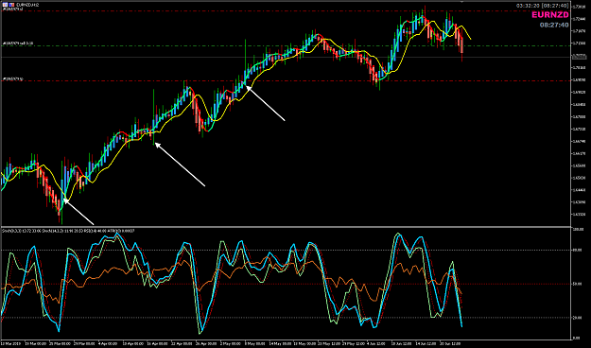
Honesty is a very expensive gift. You wont find it in cheap people.WBuffett
1

1

Quoting jgadefelth
{quote} So the more profitable version is to not have fixed targets ? Best regards
I don't use profit targets because NO ONE has any idea how long a trend will last, AND trends are where you make the most money. They pay for your losers and can give you VERY large profits.
I ALWAYS make the market take me out of a trade by way of 2 or 3 (or more) of the 7 indicators turning in the opposite direction.
The reasoning is, the best trades never look back until they are over.
Attached Image (click to enlarge)
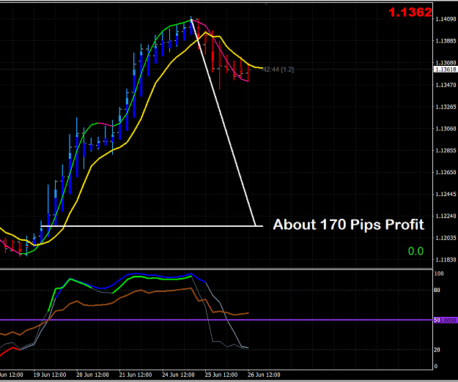
Emulate What Works

1

Quoting Atheos
{quote} Hi RH, Thank you for your hard work and wisdom on this thread. I have a question about your above comment - please can you explain in a bit more detail what the significance of the dark blue/light blue etc is and what this tells you. Your comments in post 1 reference it but I am not quite understanding. Thanks in advance.
When they are blue/blue it means UP.
When they are red/red it means DOWN.
When they are blue/red they are in transition.
Only initiate trades when they are blue/blue or red/red.
Emulate What Works

Quoting Zimbinga
{quote} So you can look for set ups likely to convert into a higher TF trade, where set up looks close on higher TF or is actually ready on higher TF too. This is a form of MTF analysis. - I seem to recall Big E said he did not do this, but some TMS traders do and did trade in line with higher TF.
Trading longer time frames usually yield better profits, so if a 4 hr. trading is trending well and the Daily chart later says to enter, why not just keep the 4 Hr. trade and turn it into a Daily trade? That's what I do any time I can.
Emulate What Works

2

Quoting lddd
{quote} Ahh, thanks! Are there any preparations you usually do when trading the 4 hour or Daily, like any specific routine to set up your charts or specific analyses, procedure you do before looking out for possible trade entries? I ask so because most topics here on FF leave out all this stuff and mainly focus on the technical indicators and what determines a valid entry or exit signal. Maybe you could write down your typical „daily routine“ to post 1 giving a quick overview about the markets you trade, if and what preparations you do (if there...
"Are there any preparations you usually do when trading the 4 hour or Daily, like any specific routine to set up your charts or specific analyses, procedure you do before looking out for possible trade entries?"
I have several Profiles set up on MT4 (each one has 6 or 8 pairs) some with all 4 hr. charts and some all with Daily charts. I just look through all of them briefly (usually multiple times a day if I am that interested) and if I see a set up I love, I might take it. And the ONLY thing I EVER USE is the #1 Template on every chart.
Maybe you could write down your typical „daily routine“ to post 1 giving a quick overview about the markets you trade, if and what preparations you do (if there is more then just spotting the right indicators condition), what session/s you trade, what time zone you are and how many trades trades you have on average per week or month following such routine.
Honestly, I have no typical routine in any way. I have been self-employed for over 40 years. I have never had a job. I have ALWAYS owned a business since I was 14 years old. For more than 1/2 of that time, including the last 21 years, I have worked from home. I invent, design, and manufacture products (currently I have 335) and sell them to Walmart, Sears, Home Depot, Amazon, etc.
Sometimes I trade none in a day and sometimes I trade all day long, and sometimes I do neither. Sometimes I sleep during the day and work at night. Sometimes I go to sleep at 8 pm and get up at 2 am. Sometimes I just do nothing all day and sometimes I binge watch TV series on Netflix, HBO, Showtime, etc. all day.
I live down a long dirt road inside of 30 acres that can never be built on near the ocean (strangely enough inside of New England's best beach town according to the Boston Globe readers) BUT I rarely leave home except to travel. I travel quite a bit because since I work from home, I do need time away from home for a change of pace and scenery.
The point is, just as I said, I REALLY have no typical day or routine. I have no typical number of trades a day or week or month. I don't honestly care which pairs I trade, although I do like the JPY crosses the best BUT only because typically THEY MOVE A LOT MORE (in pips) than most of the other commonly traded pairs.
The only definitive answer that you asked that I can give you is...I live in the Eastern Time Zone.
Emulate What Works

7

Quoting kirinda
{quote} Exit with 57 pips in profit {image}
one of the best trades I seen posted this week...  
good entry with good exit.
very nice breakout after a period of consolidation .
well done.
people should save his chart and learn from it and look for similar kind of market conditions and take trades every week... work in all timeframes from M15, H1, H4 to D1.
Attached Image (click to enlarge)
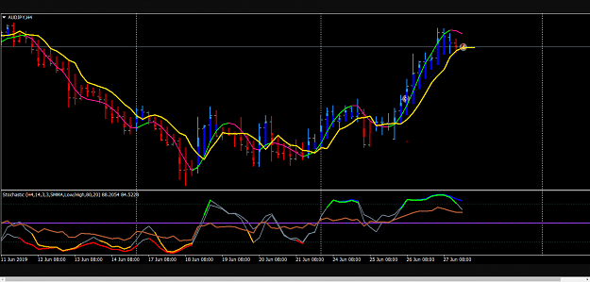
Honesty is a very expensive gift. You wont find it in cheap people.WBuffett
1

1

6 Continuation Trades
How much easier can trading get than this ???
Attached Image (click to enlarge)
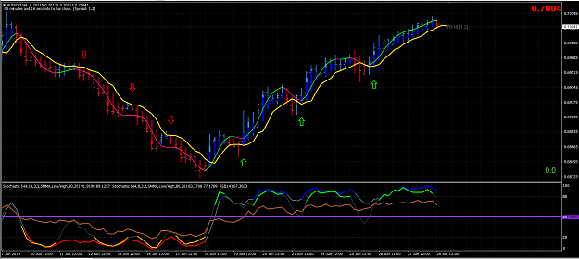
Emulate What Works

5

I would start looking at the Weekly chart to see if there is a CROSSOVER setup using RH six conditions in Post#1
Crossover Trades:
1. The HMA Line is Lime Green and crosses above the Yellow Line for long trades OR the HMA Line and is Deep Pink and crosses below the Yellow Line for short trades.
2. The candles must have just changed from Dodger Blue/Blue to Red/Maroon for short trades or from Red/Maroon to Dodger Blue/Blue for long trades.
3. After both # 1 and # 2 above have occurred, preferably, you want to initiate a trade after the 1st bar has closed on the same side of the Yellow Line as the direction of the trade or on the 2nd or 3rd candle ideally. Entering any later than that is more risky.
4. The trade set-up bar is the 1st candle to cross over the Yellow Line AND is the opposite colors of the previous candles. Both bars must either be: Red/Maroon or Dodger Blue/Blue. Red/Maroon for short trades or Dodger Blue/Blue for long trades. The set-up candle must close before you enter a trade.
5. The 2 Stochastic Lines must be above, or crossing above the Purple 50 Line for longs OR below for shorts.
6. The RSI Line (Brown) must be on the same side of the Purple 50 line as the direction of the trade at the time of entry.
This is what makes it Trading Made Simple(r) before we even go into talking about price structure in lower timeframes.
Look at AUDNZD W1 as example, how many W1 Crossovers were there that provided good trades in lower timeframes?
Next week, do we prefer to look for sell or buy?
Attached Image (click to enlarge)
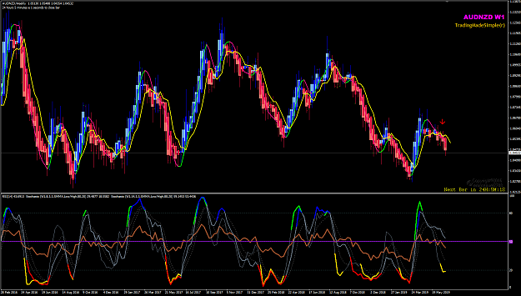
Honesty is a very expensive gift. You wont find it in cheap people.WBuffett
1

4

Quoting Giedrius
I would like roll out some discussion if someone is at the screens this weekend, and as more answer as possible would be beneficial for everyone , I think . What you want see on Daily chart before you take trade on 4 hrs. chart . All indies are in place and you ready to trigger, in which positions you want to see a Stochastics and RSI in lower window?. I understand it is no one answer, but maybe is one or two which are working best. Stochastics and RSI crossed 50 in yours direction , Stochastics and RSI close to cross it , Stochastics and RSI bellow...
Hi Giedrius
I swing trade on Daily and Weekly charts timeframes.
Since we have June month closed on Friday, I would look at my Monthly charts and get an update of the market condition.
And on my weekends, I prepare my week trade plan.
First thing I do is to look at the economic events calendar and take note of the tier one type news/data release. And also other events not on any calendar like the concluded G20 meeting and the Trump-Kim meeting at the DMZ.\
Once I have my view of all the MN charts of my 20-pairs, I will know what to look for next and also how I would be managing all my open positions from the previous week.
I see two new potential on my MN charts below.
But these are MN timeframes , and the next task is to drill down to the Weeky to get a quick top down analysis.
I would be looking for correction trades on either Daily and also H4 is possible. by always prepared when the swing high during this month is seen then prepare the ride the MN down.
Attached Image (click to enlarge)
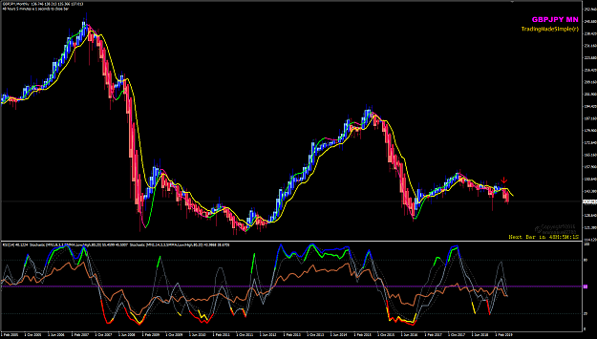

Attached Image (click to enlarge)
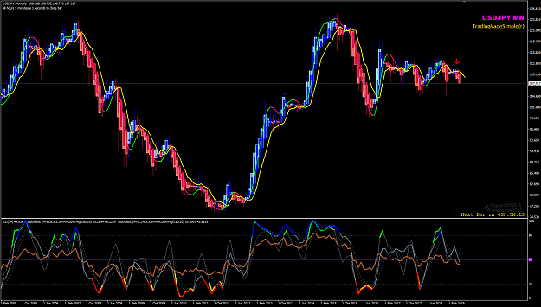
Of course, there are CONTINUATION potential possibilities in the other pairs.

Quoting salimc
Hello RH, Is this a valid setup? Because in H4 and Daily they agree but in weekly they don't agree. Thanks. {image} {image} {image}
I don't review the weekly chart before I enter a trade.
NORMALLY, I get my entry signals from the 4 Hr. chart, but I USUALLY look at the Daily chart first.
Then sometimes that 4 Hr. trade I keep and then if or when the Daily chart gives me a trade in the same direction, I keep it and start following it on the Daily chart.
Emulate What Works

1

Quoting Rob_Trader
{quote} And what do you do if you have to leave two hours before the news and know that you will not be back until an hour after the news?
I "fly" by the instruments ONLY just like a professional airline pilot. Whatever they tell me to do, I do.
I put in my stops and whatever happens happens. It's that simple.
The exceptions may be things like I am going on vacation, I get sick, etc. and therefore I can't trade.
See, here's the thing...
NONE of that stuff that everybody worries about affects my trading. Not S&R areas or lines, not previous highs or lows, not trend lines and NOT the news.
NONE of them can predict future direction of the market any better than 50/50, so why use them? and why worry about them?
By adding in that stuff, you are telling the indicators that you don 't trust them, so if that's the case then why even use them?
Are they wrong sometimes? YES!
Are they better than ANYTHING ELSE I have? YES!
You HAVE to learn to trust what they are telling you to do, AND THEN, DO IT!
Emulate What Works

12

Quoting jgadefelth
Ok RH to take a trade on 4h we must have daily all ondicators in our direction ? 2 question when a 4h trade turn into a daily trade do wd still get out on 4h ? Best regards
Q1: Ideally, they both should be going the same direction, but it's a personal choice. Sometimes I'll take a trade on a 4 hr. chart if most of the indicators (but not all 7) on the Daily chart match the 4 hr. BUT, I almost never enter a trade if the RSI is on the wrong side of the Purple 50 Line...almost never means that if the RSI is REALLY close to crossing Purple 50 Line and all (or most) of the other indicators agree, then I might enter.
Q2: That's a personal choice, sometimes I do and sometimes I don't. It's like asking if a professional baseball player ALWAYS swings at a fast ball straight down the middle, sometimes he does, sometimes he doesn't. It's a personal choice by him also.
Emulate What Works

1

Quoting PhillipmC
Fresh Cross, weekly daily up trend thoughts ? Continuation trade {image}
there is already a Weekly CROSSOVER setup when last week closed, right?
the 'perfect' CROSSOVER setup would be when all three oscillators - Stoch(8,3,3), Stoch(14,3,3) amd RSI(14) crosses the 50-level from below within 2 to 3 bars/candle. If either one of the 2 Stoch cross is much later than 4th bar/candle, it is often not the 'best' setups to pick a trade. Study old charts and observe if this is true.
so this week would be easy decision to look for buys only...but the challenge is the low timframes (D1 and H4) retracements during this week which can be difficult...
but we have he Weekly HA and APB to help use see where the calculated average price OPEN level is, right?
how do we use this Weekly HA+APB candle Open and its body?
Attached Image (click to enlarge)
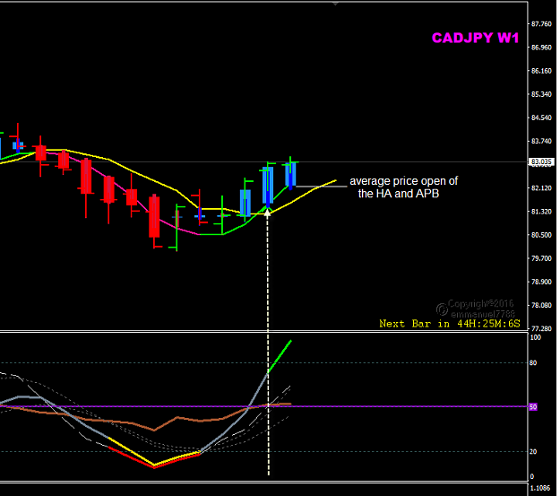
Honesty is a very expensive gift. You wont find it in cheap people.WBuffett
1

1

Quoting lddd
{quote} The rules from Post 1 should stay the same or? You probably get a lot of more signals otherwise there should be no difference instead of these signals might be not as reliable and you have to be even more selective which can easily lead to overtrading if you are not 100% disciplined. But its the same problematic with every strategy no matter what...
It doesn't matter what time frame you trade, the rules are always the same.
What people have to consider is: how do you want to get there?
By horse and buggy, by car, by train, or by jet plane?
I prefer the jet plane, which in my opinion are the 4 hr. charts and above.
Attached Image (click to enlarge)
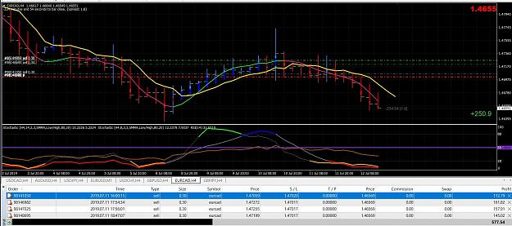
Emulate What Works

1

Quoting emmanuel7788
{quote}   I may be wrong but is this the first time you post multiple entry trades? some people will say you average down and add to a losing trade... which I would disagree with. Good trading!
No, I think I have posted some multiple trades before.
Sometimes I trade a little on a lot of different pairs, and sometimes I trade a lot on just one pair. It's just depends on what I see.
When I get all of the "stars to align" so to speak, I load up.
In this case, all of the stars aligned perfectly. I took the trade on the 4 hr. chart because I got a signal to short AND the Daily chart was LIKELY to turn into a Continuation Trade down (which it did and I said so before it happened in an earlier post, # 1293) and the weekly and the Monthly charts were down.
It just doesn't get any better than that.
Emulate What Works

1

Quoting salimc
{quote} Trend lines are support or resistance and it can be broken at any time. So RH doesn't use it in his trading. You don't need a trend line for finding a setup with this system.
The reason that I don't use traditional support and resistance lines/areas (except in rare instances) is because sometimes they work and sometimes they don't. Which means that they are not reliable enough for me to use to make trading decisions off of.
It's like having a car that starts sometimes, and it doesn't at other times, but you never know when either will happen. You most likely wouldn't keep that car and so it's the same thing with traditional support and resistance lines/areas for me.
The rare times when I become "aware" of support or resistance is when the market goes to "no man's land" and by looking way back I may find a previous support or resistance area that may attract price, or repel it. BUT, even then, no matter what, I still ONLY make my entry or exit decisions using the indicators that we use. The only exception where I might use them is if there is some other reason that I need to exit such as: I am going on vacation, I am sick, or I am doing something where I will be unable to monitor the trade, and then I might exit at that support or resistance.
And for those of you who are wondering why I said that I don't use traditional support and resistance lines/areas. I do think there might be some validity to using "dynamic" support and resistance lines/areas, meaning things like: Bollinger Bands, Keltner Channels, envelopes, and the like. But the jury is still out for me.
Emulate What Works

3

Quoting RobinHood
{quote} My testing showed that 2 bars back was optimal.
Hi RH
based on your experience, when do you start move your stops using this 2bars look back?
reason why I ask is because I use THV CaveManager to manage some of my trades and its default setting is to move trailing stops TSL by trailing using 1-bar look back and only when the price has made a higher high (buy) or lower low(sell).
thanks and regards.
Honesty is a very expensive gift. You wont find it in cheap people.WBuffett
1

Quoting RobinHood
The image below is for The Spoof because he uses something similar and I told him that I would show him my version. You always start with 3 units. If successful on all 3 units, you make 6:1 R/R. OR what I like even better is, you can just let the 3 unit run and trail your stop until you get a signal to exit OR you get stopped out. {image} It's the Draw Fibonacci Retracement tool on MT4. And because I know people will ask what the settings are: {image} {image} {image}
Nice! 
I have made two MT4 scripts to draw those EP SL and TPs level..
see my Oct 2014 post# 43,061 in the TMS thread
you can download those two scripts here:
https://www.forexfactory.com/showthr...69#post7836469
if anyone wants to make changes, please feel to ask.
Edit. ***important note***
when you use those scripts, you can saved them in your Navigator Favouries folder (your frequently used scripts) and simply you drag and drop it on the specific bar/candle of your trade entry. The script will calculate the SL and TP levels using the ATR.
like in this example below.
Attached Image (click to enlarge)
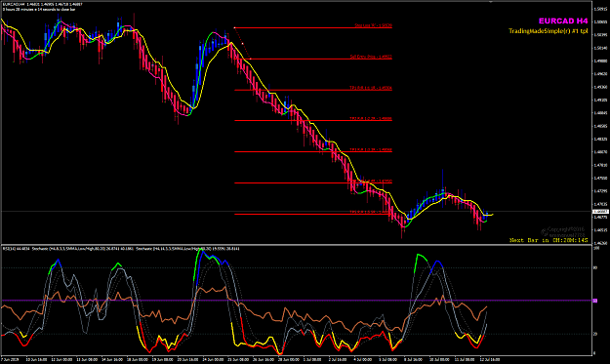
Honesty is a very expensive gift. You wont find it in cheap people.WBuffett
1

1

Example EURUSD D1 Jul 15 EP Sl and TPs
with adjusted initial SL using 2 bars/candle look back.ed
Attached Image (click to enlarge)
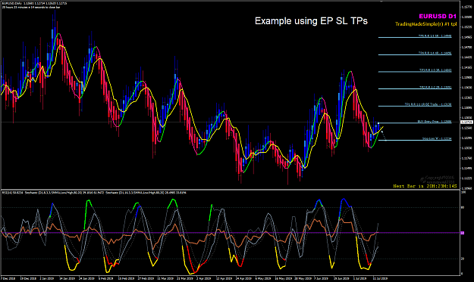
Honesty is a very expensive gift. You wont find it in cheap people.WBuffett
1

2

Quoting Bluejay12
{quote} Intresting so you use the mother D1 charts and grandmother w1 charts for you confirmation set up with Robinhood method , and once that’s confirmed you go dial down to the daughter 4h chart for entry and exit while you ride the grandmother D1 trend ? Keep enter and exit on the 4h during the enitre confirmed D1 trend set up ?
Good sense of humour calling Weekly grandmother, Daily mother and ....4Hourly daughter. LOL.
I keep a rather simple routine.
When Monday market open at my end (NY Open Sunday) I scan through my watchlist 20 pairs Weekly charts and look for new setups and if there is already an established trend after a recent CROSSOVER, I will drop down to Daily. If Weekly shows that price bars HA candles are small and trapped within its HMA and 5EMA, I skip the pair. I wait until there is a new price move outside the HMA and 5EMA.
Then I scan through all my daily charts and see if there are new CROSSOVER setups or CONTINUATION setups. If there is any, I simply open my positions.
If Daily shows established trend after a recent CROSSOVER, I'll wait on H4 for setups.
Doing it this top down approach, I will always find some good trading opportunities during the week.
How I allocate my account money to trade each pair is my other grandmother story...
Example EURJPY below,.. no trading for two weeks when price 'trapped inside HMA and 5EMA.
Attached Image (click to enlarge)
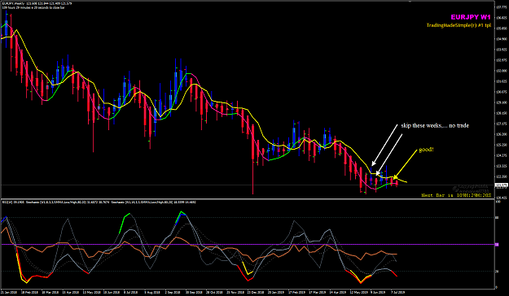
Honesty is a very expensive gift. You wont find it in cheap people.WBuffett

4

Quoting Bluejay12
Any one in any active trades ? See any on the NY close ?
My ten(10) trading tasks:
After NY Closed and new Sydney D1 Open , I check all 20 pairs for fresh and new CROSSOVER setups ... Today Jul 17 Sydney Open, there is no D1 CROSSOVER so my task is look for CONTINUATION setups today.
For those pairs which are already in their established trend/swing, my other trading tasks is to look at all open positions/baskets and do scaling-in more positions. I can do this any time today... can do it on H4, can do it on H1, ... whenever I have time to.
Some pairs which I have open positions/baskets, I look at the $$$money profits and 'sweep these back to my bank'.
So far this week, I must thank Boris Johnson and his no deal Brexit stance. If he becomes PM and hold early elections, I am afraid his party will lose the majority. 
Honesty is a very expensive gift. You wont find it in cheap people.WBuffett

2

Here is an example using script to plot the EP SL and TPs using R and R-Mutliple exit management.
EURAUD Jul18 H4
Attached Image (click to enlarge)
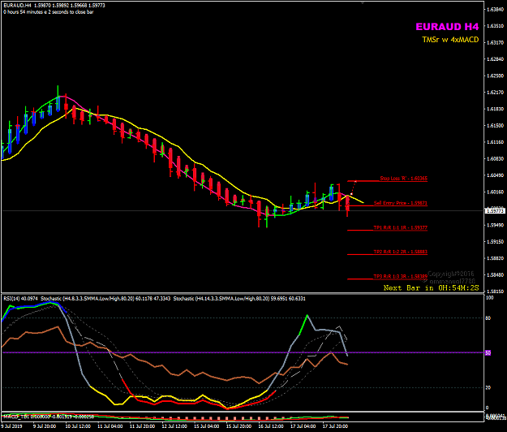
Honesty is a very expensive gift. You wont find it in cheap people.WBuffett

Another example using EP SL and TPs levels with additional -0.5R between EP and SL
AUDUSD Jul18 H4
this is a breakout setup with CROSSOVER
Attached Image (click to enlarge)
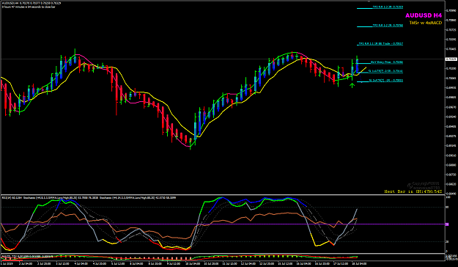
Honesty is a very expensive gift. You wont find it in cheap people.WBuffett

Quoting emmanuel7788
Another example using EP SL and TPs levels with additional -0.5R between EP and SL AUDUSD Jul18 H4 this is a breakout setup with CROSSOVER {image}
Attached Image (click to enlarge)

with less than one hour to H4 close, trade management decision ...
anythingcan happen during NY session until London close today.
move all positions to BE and get free trades.
Attached Image (click to enlarge)
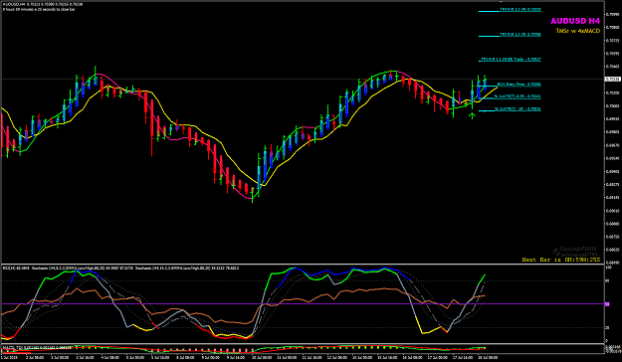
Honesty is a very expensive gift. You wont find it in cheap people.WBuffett

1

Quoting emmanuel7788
Here is an example using script to plot the EP SL and TPs using R and R-Mutliple exit management. EURAUD Jul18 H4 {image}
Attached Image (click to enlarge)

looking at the situation right now, it is unlikely to make it to TP1 level.
if it does, then take out one lot at +1R and BE remaining 2 lots and wait.
Attached Image (click to enlarge)
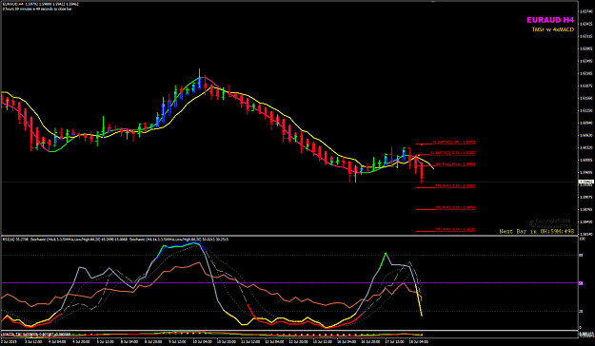
Honesty is a very expensive gift. You wont find it in cheap people.WBuffett

1

Hi Guido,
We usually like to give each trade some 'room to breathe' hence not to place our initial SL too close to the Entry Price.
One way is to use the volatility. For EURAUD, the H4 volatility is higher than other USD major pairs, so using 2 times the ATR(10) would roughly give 93 pips as initial SL which is the trade Risk or 'R'.
Another way is to place the initial SL using the 2-Bars Look Back method, i.e. to place the iSL at the high of the previous 2 bars. In this example, that would also be where the last swing high was. That would be 'safe' technical stop to use.
Attached Image (click to enlarge)
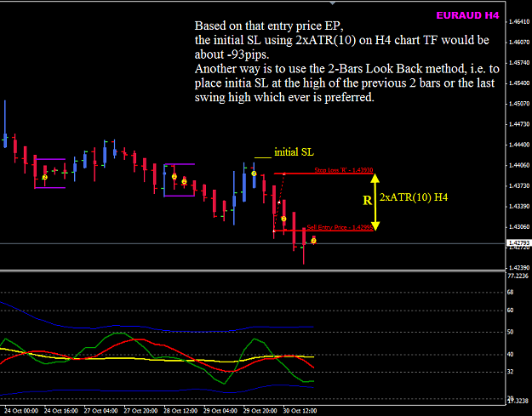
I have two script which I use to draw the EP SL and TP lines as shown in above chart. These script will calculate the ATR and use that to plot the iSL and TPs levels using the ATR of that chart TF at the moment when you made that entry.
Simply drag and drop the script to the exact point of your trade Entry.
These two scripts are attached, latest version on MT4 build 735.
I know the SL 93pips may be big when we trade with fix lot size. But when we use the % risk model and with position sizing and calculate the lot size using the R, the risk % is still the same.
The Exit Strategy is important and when we want to give priority to Capital Protection, we can move our iSL quickly when there is floating profit. How to determine the floatng profit to move the stop requires us to look at the price action.
regards,
Attached Files
Draw_Lines Sell EP SL TP v4.ex4 6 KB | 720 downloads
Draw_Lines Buy EP SL TP v4.ex4 6 KB | 699 downloads

I did not say the volatility is high. I only want to show the hourly volatility is distributed throughout a 24 hour day so that we know which are the best hours of the day to trade for every pair.
Look at EURUSD and GBPUSD, these two pairs are good to trade from Frankfurt Open up till London close. When trading H1 and below, you just need to be careful at those hour when Tokyo session closing hour and before NY open hour, and the overlap hours of London and the NY sessions.

We see weaker GBP, so why not take a look at GBPUSD, GBPJPY, GBPAUD, GBPCAD and GBPNZD.
Look for sell opportunities and make some money this week.
Wait for a retrace on M5 and jump in with smaller SL.
All we need it the seven (7) indicators RH' Post#1. Anything else added to the seven (7) only leads to fewer trade opportunities.

Quoting jgadefelth
{quote} 1:1 trades ? how high do you think the winning percent will be ? Also do you surgest any speciell pairs ? Best regards
I have NO IDEA what the winning % will be. There are too many variables that can't be quantified among different traders. This exercise is not MAINLY about the winning %. The most important part is about executing trades according to a set of RULES and sticking to them, which most newer and undisciplined traders are NOTORIOUSLY BAD AT.
Special pairs? It really doesn't matter, but if I had to chose, I would suggest some of these:
AUDUSD, GBPUSD, EURUSD, USDCHF, USDJPY, USDCAD, NZDUSD
Emulate What Works

Quoting lddd
{quote} Why it´s so important to catch a big run/trend and open multiple positions with complex entry/exit methods monitoring a dozens of currency pairs/markets to find that perfect H4/Daily/Weekly condition trade setup "maybe" booking in hundrets of pips on a good run? I just ask so because i don´t really understand the logic behind it. I mean isn´t a 25-50 Pips+ by the end of each trading week not enough for people if this could be even achieved on trading just one market with maybe 2-3 trades per week investing 2-3 hours of time per day. (even...
I think RH means big enough swings to catch a decent RR. I am shooting for at least a 2R trade and for me that is too tight of a stop on lower time frames. The stops are way too close to intraday price action for my tastes. Even the 4 hour is getting close as there are 6 candles in each day but I like the swings on the four hour - plenty of 2R+ swings to be had. Plus, after years of trading lower time frames I can't deal with the stress and boredom.
As far as risk goes, everyone is different. I don't trade pips. I don't look at pips - ever. Dollars pay the bills not pips. I trade dollars and I trade aggressively by most standards. I trade a set dollar amount for each trade and that dollar amount is based on being able to sustain 20 straight losses in a row. Once my account grows to a level I am satisfied with I increase the dollar amount and stay with it until I feel like increasing it. If you must know, the dollar amount works out to 5% at the very beginning of a new level and then obviously gets less as a percentage as the balance grows, but the dollars risked is always the same on every trade until the next level. I am not afraid to have a decent size risk because I trust in my methodologies and I don't take very many full 1R losses because I shed risk as the trade goes on. If I take a full 1R loss the trade is usually going against me anyway. I think these tiny risk percentages 1-3% are reflective of fear and doubt in one's trading, the inability to stick with a plan, good money management and keeping emotions out of trading. Unless you have a massive account, trading small percentages will get you nowhere. IMO 

Quoting TheSpoof
{quote} I think RH means big enough swings to catch a decent RR. I am shooting for at least a 2R trade and for me that is too tight of a stop on lower time frames. The stops are way too close to intraday price action for my tastes. Even the 4 hour is getting close as there are 6 candles in each day but I like the swings on the four hour - plenty of 2R+ swings to be had. Plus, after years of trading lower time frames I can't deal with the stress and boredom. As far as risk goes, everyone is different. I don't trade pips. I don't look at pips - ever....
I mostly agree. Well said.
Personally, the only thing I would do different using that type of profit strategy is trade in multiples of 3 units.
Initially you start with your stop at -1R on 3 units - If price goes to -1R before you get to +1R, you lose 3R.
At +1R, exit 1 unit and move the stop to breakeven (which is 0R, that's ZERO R) on the other 2 units. - If price goes back to +0(ZERO)R before you get to +2R you make 1R on 1 unit.
At + 2R, exit 1 more unit and move your stop to +1R - If price goes back to +1R before you get to +3R, you make 2R (1R on 2 units)
At +3R, move your stop to +2R and trail the stop on the last unit every 1R extra in profit. - If price goes back to +2R before it gets to +4R, you make +3R (1 at +1R, 2 at + 2R = +3R)
At +4R, move your stop to +3R and trail the stop on the last unit every 1R extra in profit. If it goes back to +3R before it gets to +5R, you make +6R (1 at +1R, 2 at + 2R and 3 at +3R = +6R)
Then, let the 3rd unit run UNTIL 2-3 of the indicators reverse or cross the Purple 50 Line in the opposite direction of the trade.
That way, if there is a nice long orderly trend, you still get to ride it with one unit, trailing your stop all the way along until you are stopped out OR 2-3 of the indicators change.
* I hopefully have the math correct, if not and someone points it out, I will correct it.

Quoting RobinHood
{quote} I mostly agree. Well said. Personally, the only thing I would do different using that type of profit strategy is trade in multiples of 3 units. Initially you start with your stop at -1R on 3 units - If price goes to -1R before you get to +1R, you lose 3R. At +1R, exit 1 unit and move the stop to breakeven (which is 0R, that's ZERO R) on the other 2 units. - If price goes back to +0(ZERO)R before you get to +2R you make 1R on 1 unit. At + 2R, exit 1 more unit and move your stop to +1R - If price goes back to +1R before you get to +3R, you...
My concern with this sort of idea is the pain from 4+ losses in a row is going to be deep and may take some time to recover. I am not sure I want to be lessening my position as the trade moves deeper into profit  I'd rather be on board with a full load 
Emotion - it steals your money.

Quoting TheSpoof
{quote} My concern with this sort of idea is the pain from 4+ losses in a row is going to be deep and may take some time to recover. I am not sure I want to be lessening my position as the trade moves deeper into profit  I'd rather be on board with a full load 
How is my way any more likely to have 4+ losses in a row versus the way you are doing it ?
Your way initially risks 1R and so does mine.
My way you can simply take whatever size unit you are using as 1 unit and break it down into 3 smaller but equal units, it's the same amount of risk initially either way.
Plus, many SMART professional traders lighten the load as they move into more and more profit along the way, often using the concept that they get back their initial investment and then have what is called a FREE TRADE.
Emulate What Works

Quoting RobinHood
{quote} I mostly agree. Well said. Personally, the only thing I would do different using that type of profit strategy is trade in multiples of 3 units. Initially you start with your stop at -1R on 3 units - If price goes to -1R before you get to +1R, you lose 3R. At +1R, exit 1 unit and move the stop to breakeven (which is 0R, that's ZERO R) on the other 2 units. - If price goes back to +0(ZERO)R before you get to +2R you make 1R on 1 unit. At + 2R, exit 1 more unit and move your stop to +1R - If price goes back to +1R before you get to +3R, you...
Will work in situations when the market makes nice H4 swings...
like this example below and use multi-lots entry and scale-out.
Attached Image (click to enlarge)
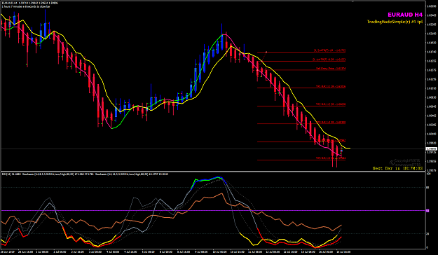
and
Attached Image (click to enlarge)
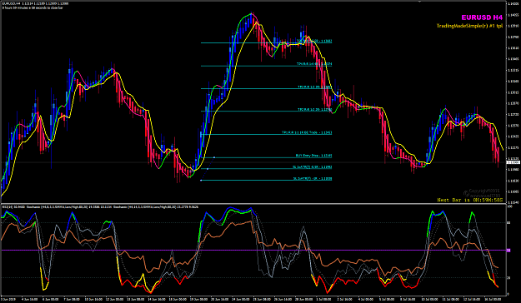
Honesty is a very expensive gift. You wont find it in cheap people.WBuffett

1

Quoting Bluejay12
Any one in any active trades ? See any on the NY close ?
My ten(10) trading tasks:
After NY Closed and new Sydney D1 Open , I check all 20 pairs for fresh and new CROSSOVER setups ... Today Jul 17 Sydney Open, there is no D1 CROSSOVER so my task is look for CONTINUATION setups today.
For those pairs which are already in their established trend/swing, my other trading tasks is to look at all open positions/baskets and do scaling-in more positions. I can do this any time today... can do it on H4, can do it on H1, ... whenever I have time to.
Some pairs which I have open positions/baskets, I look at the $$$money profits and 'sweep these back to my bank'.

So far this week, I must thank Boris Johnson and his no deal Brexit stance. If he becomes PM and hold early elections, I am afraid his party will lose the majority.

Honesty is a very expensive gift. You wont find it in cheap people.WBuffett

2

Some of you shorted AUDUSD H4 today ... you are very brave traders today.
I prefer to remain long bias on my Weekly.
Attached Image (click to enlarge)
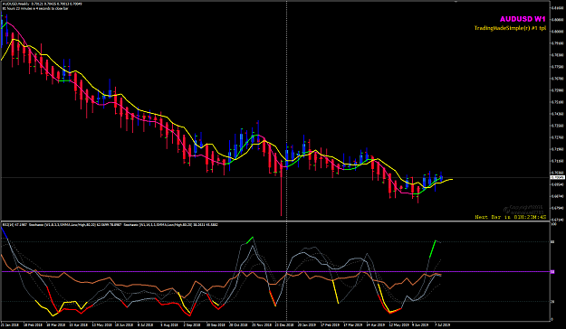
Honesty is a very expensive gift. You wont find it in cheap people.WBuffett

Quoting emmanuel7788
Some of you shorted AUDUSD H4 today ... you are very brave traders today. I prefer to remain long bias on my Weekly. {image}
I can see why you view it that way.
But, personally I see the weekly as being in flux, neither in an uptrend nor a down trend because some indicators are saying up and some are saying down. Mainly it's the RSI being below the Purple 50 Line that bothers me the most. So then we have to check the next higher time frame up, which is the monthly and it's still technically in a down trend.
My bet is that the Weekly turns into a Continuation Trade down.
Emulate What Works

Quoting 40PipsAlan
{quote} Screenshot attached. USD/CAD with a couple of arrows showing valid shorts in my opinion. I must be missing something, maybe news, or consolidation. I put the trade on and it reverses next candle. Even the continuation trades don't continue, just keep reversing. I did have some joy with the original TMS strategy as well as a double stochastic strategy but nothing consistant enough to lose the demo account. {image}
Hi Alan
Accept the fact when we trade a mechanical method using 7 indicators some trade setups will fail.
You have some good comments by other members already, read them and learn from those comments and observations made.
Important that we understand that this method is trading with price momentum.
I just want to add how I pick the 'best setups'. I trade price action therefore I look at both the price bars and the APB/HA candles.
The 'best setups' are those when the conditions are 100% within APB/HA candles 2 to 3, maximum 3 candles for CROSSOVER setups. For CONTINUATION, it is 2 APB/HA candles.Anything more than 2 to 3 candles has more risk especially when the candle are larger than normal.
On your chart with two arrows I label them 1 and 2. Note how many candles were those setups.
There were two very good setups I marked as CROSSOVER , note the number of candles when the Stoch(8,3,3) & (14,33) crosses plus he RSI(14) cross near the 50-level. For the CONTINUATION setup note the number of candles when the two Stochs and RSI show the downward momentum.
Attached Image (click to enlarge)
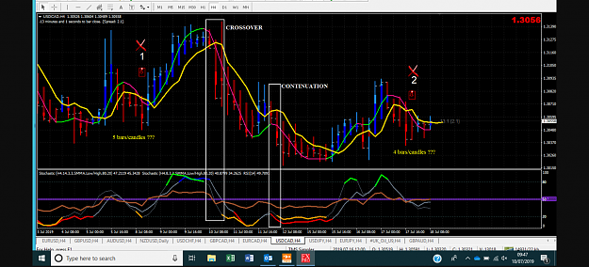
Keep on learning. Do not give up. It will need lots of screen time and practice in live market.
Honesty is a very expensive gift. You wont find it in cheap people.WBuffett

4

Quoting TheSpoof
Well, that sucks. Not much you can do about these things except a wider stop but that comes with its own challenges. {image}
Yeah, it sucks, but DON'T use a wider stop. If anything, use a smaller one, but not bigger.
Just remember this: "The Best Trades Never Look Back"
But you never know which trades they will be.
So when you bait the hook, know going in that you are going to lose your bait sometimes but overall, by following these methods CONSISTENTLY, you WILL go home with a lot more that you lost.
Emulate What Works

3

Quoting marcara
{quote} Yes, That sucks butnow with a wider SL. From my point of view, If an important data is coming, You can close the position before the data and take some green pips or move the position to BE and wait. I usually move to BE, but most trades are closed in BE. So, I am thinking on closing the trade before the data news to avoid the volatility problem.
It won't have a positive effect overall.
News happens all day, every day in every heavily populated country all around the world and you can't possibly keep up with that.
So let's look at it from a logical standpoint...
Doing what you are suggesting, you will save pips about 50% of the time OR you would have made pips about the other 50% of the time.
But when the news goes against and you lose pips, you can mostly limit the losses by using a stop.
And when the news goes for you and you win pips, there is technically no limit to the upside that you can make.
This is WHY I ignore the news and why I ONLY fly blindly by doing ONLY what my indicators tell me to do. Or I get stopped out.

Quoting MyProfit
Yes, I see a continuation to 0.9318 (a few pips more or less). And after that, a retracement to the 0.9220, then it will continue Up.. Let's see..... By the way Emmanuel, do you have a method or template where you save the probables trades for the new week, I mean a Pdf or Excel where we can annotate or input the next trades? to keep it handy...
I have updated my watchlist with another group below. Just added a few SGD pairs (Group#6) because I moved to a Singapore based MT5 broker this month.
I have my own tools for my trade planning which I keep on my server cloud storage which I can access at anytime form anywhere.
You can start use a simple spreadsheet and have each column for Weekly | Daily | H4
Note: I don't overtrade despite having 25 pairs in my watchlist. I pick one pair setup each time from each group. I trade longer term swings on Daily and Weekly. I and trade each pair with same amount of money allocated per pair, e.g. $10k for each pair up to maximum 5 pairs for a $50k account deposit. Always use risk R per currency trade traded with a cut loss plan in place and avoid running with floating drawdown of more than two weeks in any single pair traded. Do not run trades with floating DD of more than 15%. Once I see floating DD of 10% I prepare to look for exit and cut-losses, usually 10% to 15% I will cut some losses. I leverage on trading multiple pairs using money management strategy.
Group#1 (USD)
AUDUSD
EURUSD
GBPUSD
USDCAD
NZDUSD
Group#2
EURAUD (EUR)
EURNZD
EURCAD
EURGBP***
Group#3 (GBP)
GBPAUD
GBPNZD
GBPCAD
Group#4 (JPY)
USDJPY
AUDJPY
EURJPY
GBPJPY
SGDJPY
Group#5 (COMMODITIES)
AUDCAD
AUDNZD
NZDCAD
Group#6 (SGD)
AUDSGD
EURSGD
GBPSGD
USDSGD
NZDSGD
From these above groups, I see some good trade opportunities next week. You just start look at all Weekly charts and pick one from each group.
We can compare notes later when NY open a new Weekly candle.
Honesty is a very expensive gift. You wont find it in cheap people.WBuffett

